Equatorial Guinea

## Political Stability Estimate Data

The data set shows the political stability estimate of the country each year.

## # A tibble: 19 x 5  
## country iso3c date stability stabilityCategory4   
## <chr> <chr> <dbl> <dbl> <chr>   
## 1 Equatorial Guinea GNQ 1996 -0.133 moderately unstable  
## 2 Equatorial Guinea GNQ 1998 -0.0807 moderately unstable  
## 3 Equatorial Guinea GNQ 2000 -0.0411 moderately unstable  
## 4 Equatorial Guinea GNQ 2002 -0.522 moderately unstable  
## 5 Equatorial Guinea GNQ 2003 0.113 moderately stable   
## 6 Equatorial Guinea GNQ 2004 -0.0617 moderately unstable  
## 7 Equatorial Guinea GNQ 2005 -0.393 moderately unstable  
## 8 Equatorial Guinea GNQ 2006 0.166 moderately stable   
## 9 Equatorial Guinea GNQ 2007 0.256 moderately stable   
## 10 Equatorial Guinea GNQ 2008 0.204 moderately stable   
## 11 Equatorial Guinea GNQ 2009 0.373 moderately stable   
## 12 Equatorial Guinea GNQ 2010 0.236 moderately stable   
## 13 Equatorial Guinea GNQ 2011 0.150 moderately stable   
## 14 Equatorial Guinea GNQ 2012 0.233 moderately stable   
## 15 Equatorial Guinea GNQ 2013 0.120 moderately stable   
## 16 Equatorial Guinea GNQ 2014 -0.374 moderately unstable  
## 17 Equatorial Guinea GNQ 2015 -0.205 moderately unstable  
## 18 Equatorial Guinea GNQ 2016 -0.141 moderately unstable  
## 19 Equatorial Guinea GNQ 2017 -0.148 moderately unstable

## Political Stability Estimate Plot

The plot shows the trends of stabilization and destabilization for the each country.

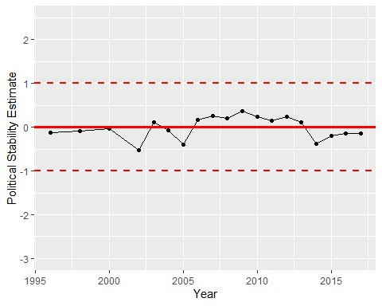

Political Stability Trend